Presentation to the Sutton Association for the Blind
(Tuesday 15th September 2009)

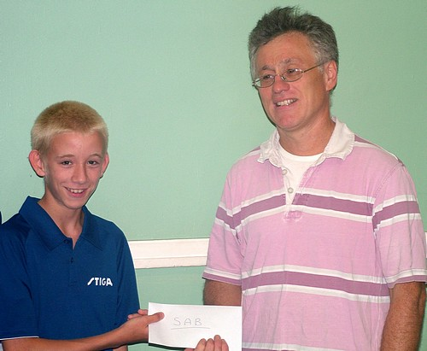
Photo 1

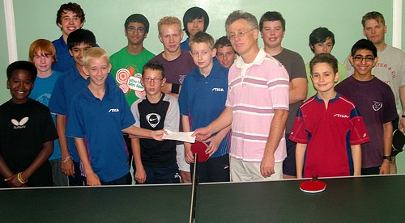
Photo 2

Derek Forbes, Chief Officer of Sutton Association for the Blind is presented with a cheque for �700 this week by
14 year old Robert Loveder who represented the players of Wallington Crusaders TTC.
The recent table tennis marathon raised a staggering �1,400 which was shared equally between the Club and SAB.

